User manual for «Admin» program

The admin program is a program designed for use at local offices and HQ for administration of the data going in and out of the tablets:

* Downloading the prices collected from the server and extract them from the CSPro format to be usable in the powerbuilder system.
* Uploading files extracted from the powerbuilder system for the tablets to use during price registration.

While the local offices only have access to deal with their own data, the user CPI_admin can administer all data.

# Prerequisites and file hierarchy

* CSPro: To run the program, the most recent version of CSPro must be installed on the computer.
* Notepad++: This is a text editor which is suitable to fix issues with the powerbuilder files

The admin program is to be found in the admin folder in the CPI file hierarchy. In here, there are three sub folders too:

* Data: This is where the price data collected in a given month and downloaded from server (after running the program) is to be found.
* UploadToServer: The monthly powerbuilder files that need to be uploaded to the server should be put here. Otherwise the program won’t find them
* Junk: The files here can be ignored.

The program itself can be started by double clicking on the file admin.pff (he one with the traffic light icon):

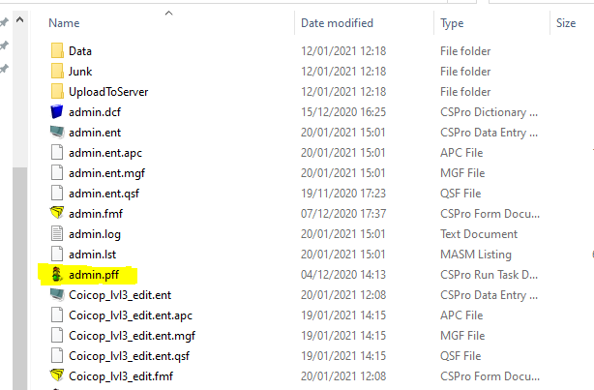

# Preparation of powerbuilder files - Setting the right charset and encoding

The program does a very primitive check of some of the files from powerbuilder, but as it is impossible to predict all possible errors, it is extremely important to open each file in an editor (for instance notepad++) and check that the files are OK.

The system needs the following 5 files from powerbuilder (MM = month, YY = year)

* BLTA_MMYY: prices collected last month from shops
* BLTB_MMYY: Prices collected last month from markets
* BLTm_MMYY: prices collected last month for monitor survey from shops
* BLTmB_MMYY: prices collected last month for monitor survey from markets
* D_perexid_MMYY: info to collect price collectors to product numbers
* D_reestr_MMYY: Price collector IDs and names
* D_rinok_MMYY: info about markets and IDs of responsible price collectors
* D_shop_MMYY: Info about shops and IDs of responsible price collectors

## Setting the right encoding

Each of these files must be given the correct character set. This can be done using for example the editor notepad++:

* Open the file in notepad++.
* Click on “Encoding” – “Character sets” – “Cyrillic” – “Windows-1251” (When the character set is correct, the Windows-1251 should have the tick like the “Macintosh” charset has below)  
    
  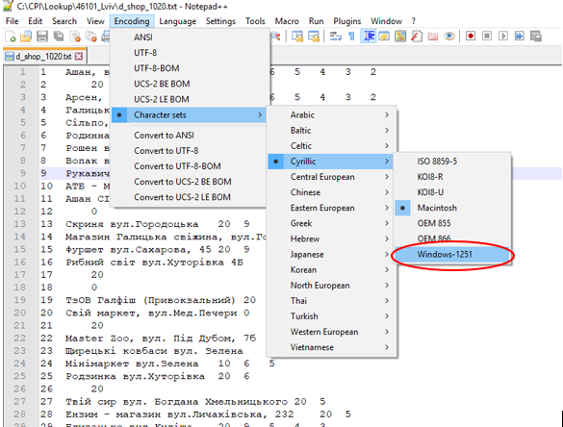
* Next: convert to UTF-8-BOM: Click on “Encoding” – Convert to UTF-8-BOM:  
    
  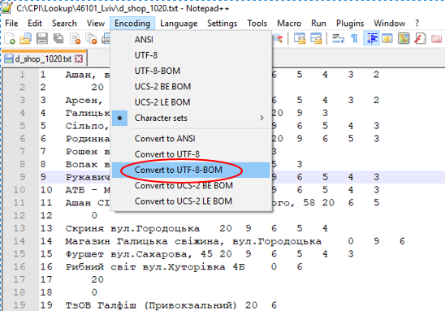
* When the setting for the file is correct, it should look like this:  
    
  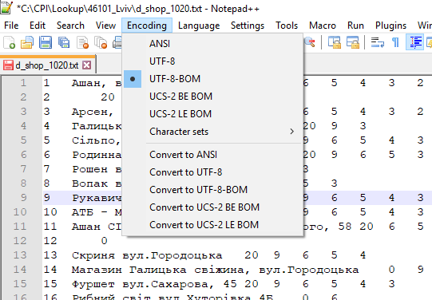

**It is extremely important that this is correct for all 6 files!**

## Fixing errors in price files

There are often line breaks that should not be there in the BLTA and BLTB files, and they are easily seen when looking at the files using notepad++ again. All extra line breaks need to be removed:

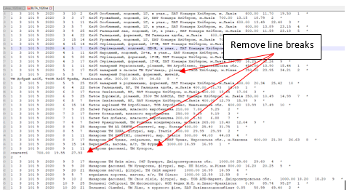

## Other errors

Open all files and check that they look OK. For instance

* that they are not shifted left: the first positions in each line should be numbers
* hat there is no “header” line with column names
* …

## Save the files

The files to upload must be stored in the folder called UploadToServer:

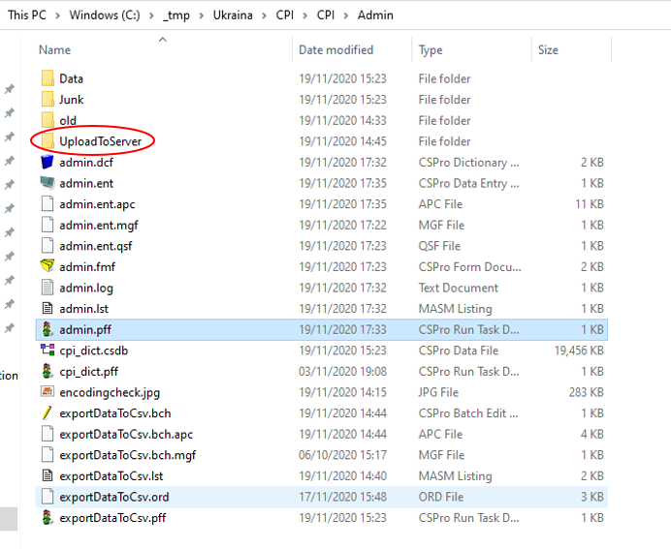

## Upload monthly files to the server using the CSPro program

In the CPI\admin folder, there is a file with a traffic icon next to it. Double click on this to start up the program:

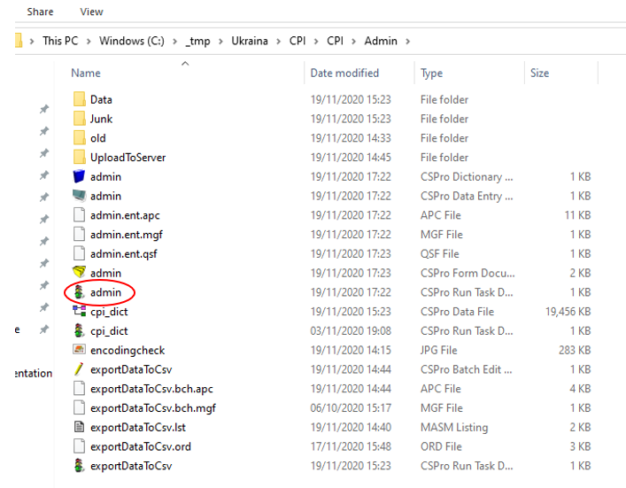

The first thing that will happen, is that you will be prompted for login and password. The login is CPI_xxxxx where xxxxx = the code of your local office. You will be prompted to set the password first time you log in.

This will open this window:

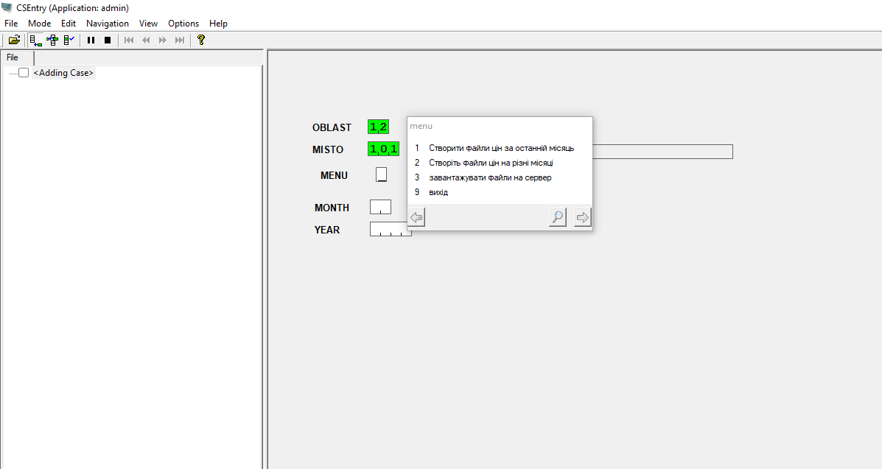

To upload the powerbuilder files to the server, select the third item on the menu. The program will then

1. Check if the files to upload exist in the UploadToServer folder.
2. Check if the BLTA/BLTB files have the right structure.
3. Ask you to double check that the encoding and the charset of the files are as described above.

If any of these checks fails, the files must be repaired before uploading. If everything is OK, the files will be uploaded to the server.

## Downloading the new price data

The same program as described above is used to download the collected price data from the server and save them as BLTA, BLTB, BLTm and BLTmB files. The default (option 1 in the menu) is to download data from *previous* month. An alternative is to manually select the month in question (you will then be prompted for month and year).

The new BLTA, BLTB, BLTm and BLTmB files files can be found in the Data folder:

